Chapter 1
Getting Started

Component List 1
Software to be Installed 1
Arduino IDE Install 2
Keil IDE Install 2
ST-Link driver Install 2
STM32 Cube Programmer Install 3
Setup Environment 3
Course Plan & Teachers 6

Component List
Links are only for reference.
- STM32 Blue Pill (STM32F103C8T6) (1 pcs) [***Important: Make sure to solder its pins from buyer] [Link]
- ST Link V2 Programmer for STM32 (1 pcs) [Make sure it has 4 female to female wires] [Link]
- 10K Resistor (10 pcs)
- 220Ω resistors (10 pcs)
- Bread Board (1 pcs) [Transparent breadboard is preferable.] [Link]
- Jumper Wire (Male to Male) (20 pcs)
- Multimeter (1 pcs) [Optional]
- 2 pin Pushbutton (5 pcs)
- LED (5 pcs RED + 5 pcs GREEN + 5 pcs YELLOW)
- 3 pin RGB LED (5 pcs)
- 10kΩ potentiometer (3 pcs)
- Photoresistor (2 pcs)
- TMP36 Temperature Sensor (1 pc)

Software to be Installed
- Arduino IDE (2.3.1) [I personally prefer 1.8.18]
- Keil uVision IDE (5.39.0.0)
- STM32 CubeIDE (1.15.0)

Arduino IDE Install
Version: 2.3.1 (Download only 2.3.1 version, not latest version)
Download Link: https://github.com/arduino/arduino-ide/releases
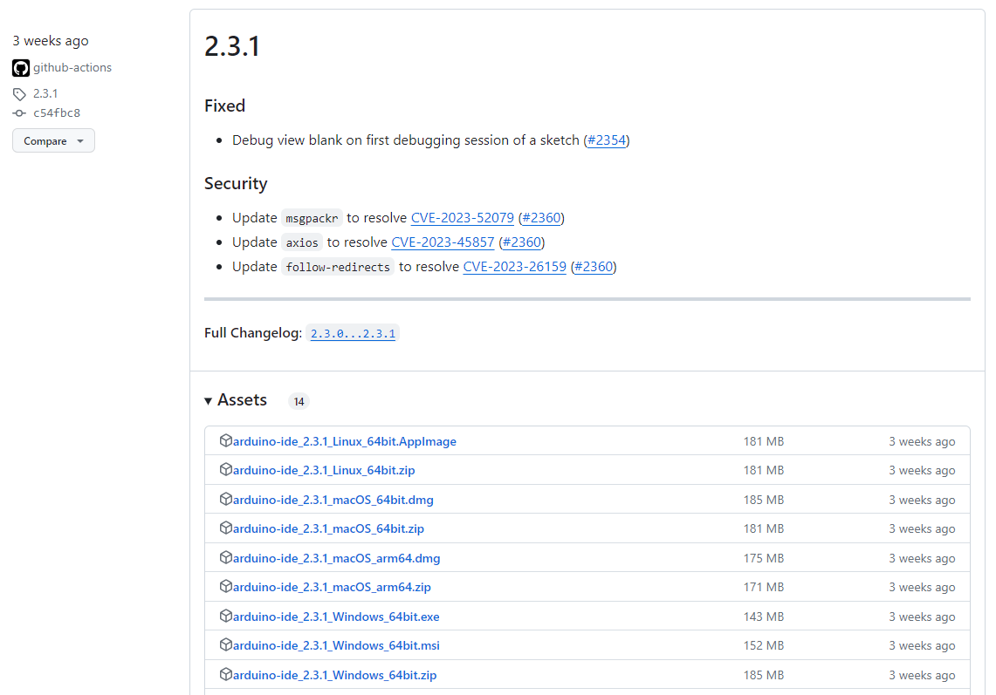

Keil IDE Install
Version: 5.39.0.0 (Fill up following form to get the Download Link)
Download Link: https://www.keil.com/demo/eval/arm.htm
Video Link: https://www.youtube.com/watch?v=buQtJjgw2pE

ST-Link driver Install
Download Link: https://www.st.com/en/development-tools/stsw-link009.html

STM32 Cube Programmer Install
Download Link:
https://www.st.com/en/development-tools/stm32cubeprog.html

Setup Environment
Select checkboxes and allow all the permissions while installing.
- Make sure Arduino IDE is installed.
- Make sure the ST-Link driver is installed.
- Make sure the STM32 Cube Programmer is installed.
- Run Arduino IDE.
- Open File > Preferences. Add https://raw.githubusercontent.com/stm32duino/BoardManagerFiles/main/package_stmicroelectronics_index.json to Additional Board Manager URLs. Select Ok.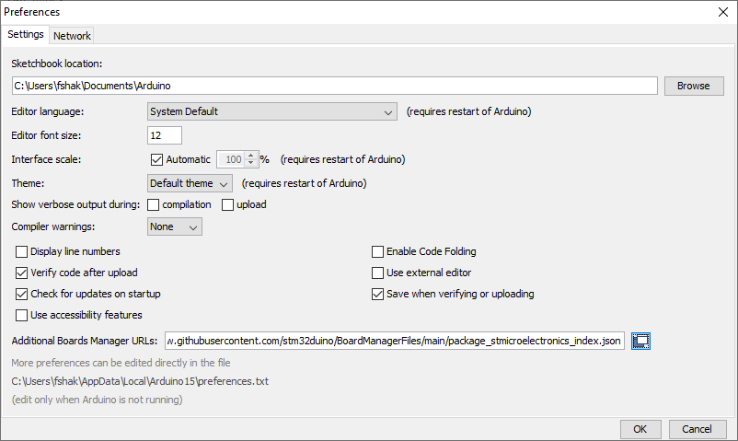
- Open Tools > Board > Boards Manager. Install Arduino AVR Boards and STM32 MCU Based Boards. 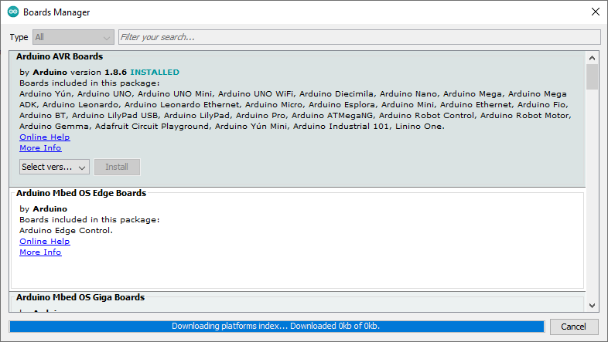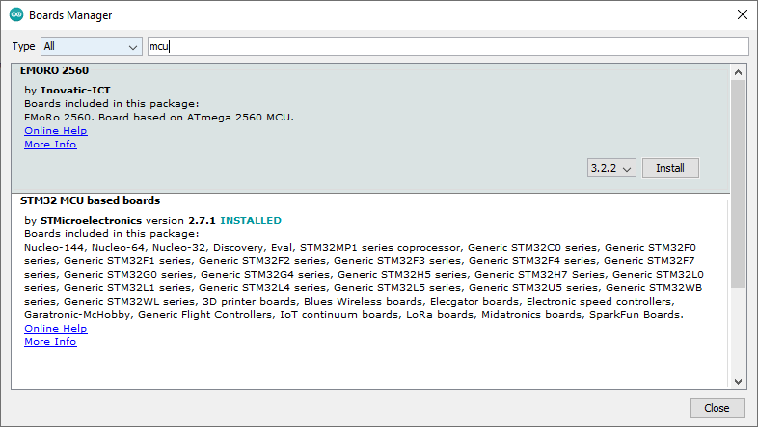
- Connect ST-Link V2 and Blue Pill using the connector and insert ST-Link to USB. ST-LINK V2 pinout positions may vary from tutorials. Make sure to check pinouts of your device before connecting.
GND -> GND
3V3 -> 3V3
SWCLK -> SWCLK
SWIO -> SWDIO
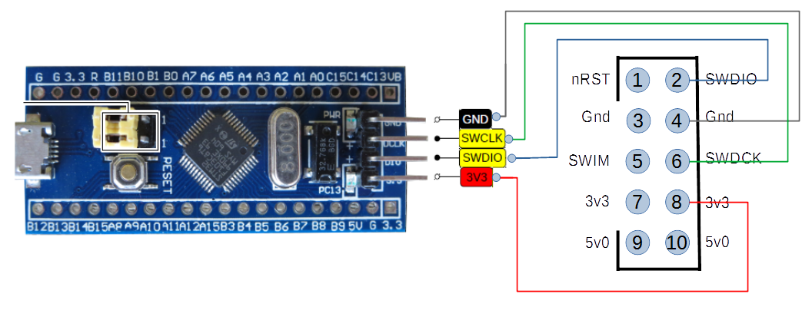[Link]
- Select board and configure according to given screenshots.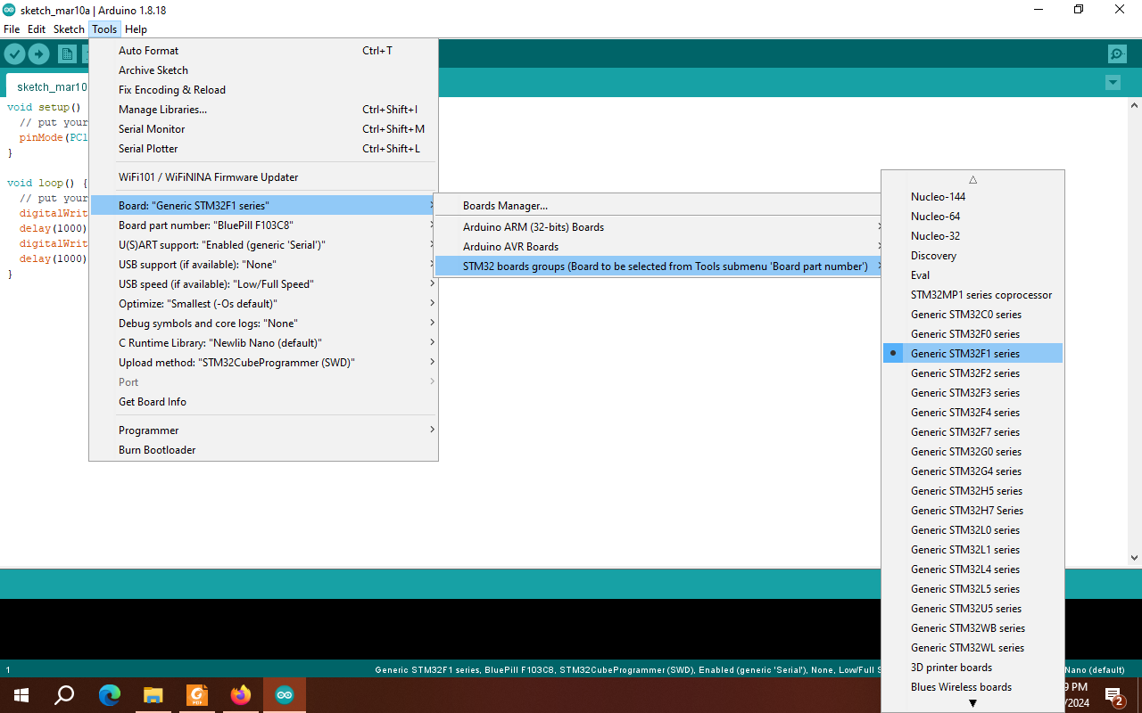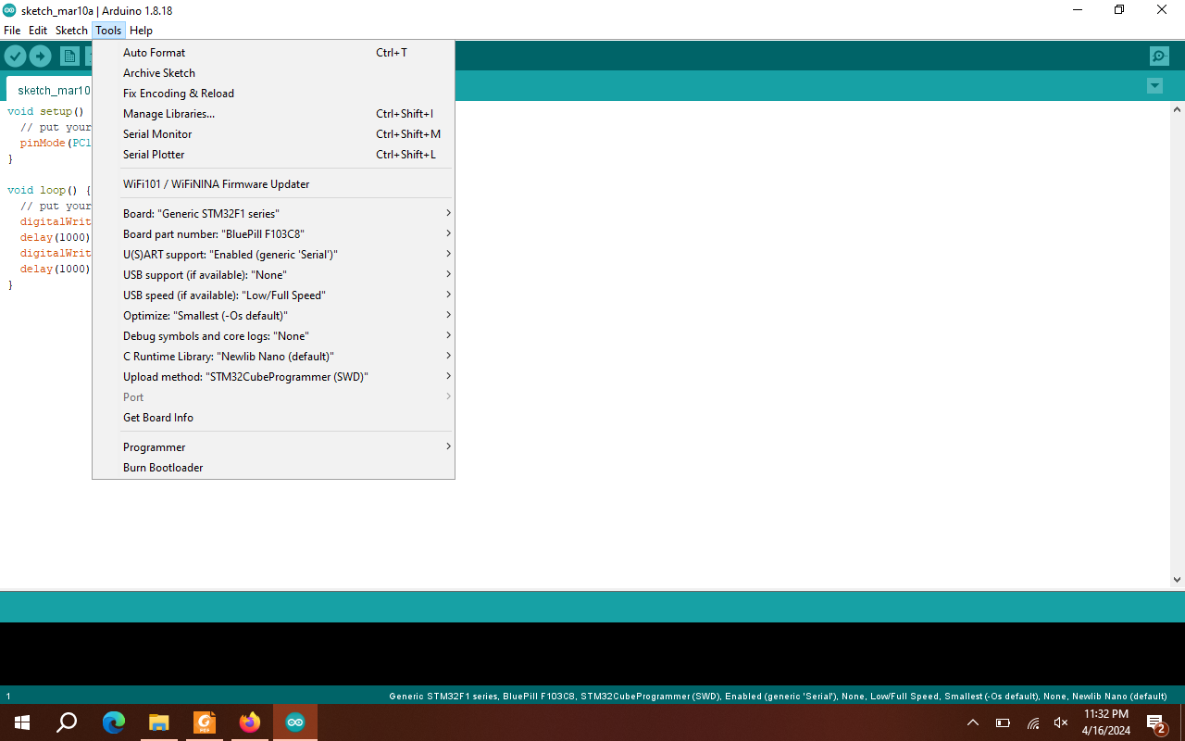

- Write your first program
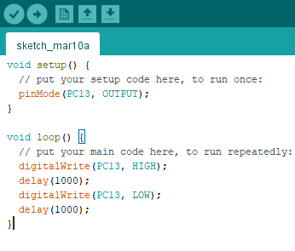
- Build and Upload.

- You should be able to see in board LED blinking.

Course Plan & Teachers
Nahin Ul Sadad, Assistant Professor, CSE, RUET
Md. Farhan Shakib, Lecturer, CSE, RUET
Md. Nasif Osman Khansur, Lecturer, CSE, RUET

